**UNLEASHING THE POTENTIAL OF**

**OUR YOUTH: A STUDENT**

**PERFORMANCE ANALYSIS**

***A project report submitted to Jawaharlal Nehru Technological University, Kakinada***

***In the partial fulfillment for the award of the Degree of***

**BACHELOR OF TECHNOLOGY**

**IN**

**DATA SCIECNCE**

***Submitted by***

**G MANISHA (20KE1A4412)**

**N M SUMA (20KE1A4437)**

**P SUVARNA (20KE1A4438)**

**P UMA MAHESWARI (20KE1A4442)**

***Under the Noble Guidance of***



**DEPARTMENT OF DATA SCIECNCE**

**MALINENI LAKAHMAIAH WOMEN’S ENGINEERING COLLEGE**

**(AUTONOMOUS)**

*(An ISO 9001-2008 Certified & NBA Accredited Institution)*

(Affiliated to Jawaharlal Nehru Technological University, Kakinada)

PULLADIGUNTA(VILLAGE), VATTICHERUKURU(MANDAL)

**MALINENI LAKAHMAIAH WOMEN’S ENGINEERING COLLEGE**

**(AUTONOMOUS)**

*(An ISO 9001-2008 Certified & NBA Accredited Institution)*

(Affiliated to Jawaharlal Nehru Technological University, Kakinada)

PULLADIGUNTA(VILLAGE), VATTICHERUKURU(MANDAL)



**DEPARTMENT OF DATA SCIENCE**

*This is to certify that the project entity “Unleashing the potential of our youth: A Student performance analysis “***is** *a bonafide work* of

G Manisha (20KE1A4412), N M Suma (20KE1A4437), P Suvarna(20KE1A4438), P Uma Maheswari (20KE1A4442), *in the partial fulfillment of the requirement for the award of the degree of Bachelor of*  *Technology in* ***DATA SCIENCE*** *and for the academic year* ***2023-2024****. This work is done under my supervision and guidance.*

**Signature of the Guide Signature of the Head of the Department**

**Yamini mam Dr. HARI KRISHNA(HOD)**

**Signature of the External Examiner**

## ACKNOWLEDGMENT

“Task successfully” makes everyone happy. But the happiness will be gold without glitter if we didn’t state the persons who have supported us to make it a success.

We would like to place on record the deep sense of gratitude to the Honarable chairperson Dr. Malineni Perumallu, Guntur for providing necessary facilities to carry the project work.

We express our gratitude to **Dr**.**J.APPARAO, Ph.D.,** principal of MLWEC, Guntur for his valuable suggestions and advices in the B.Tech course.

We express our gratitude to the **Head of the department of DS**, **Dr**. **HARI KRISHNA, MLWEC, Guntur** for his constant supervision, guidance and cooperation throughout the project.

We would like to express our thankfulness to our project guide **PRATHYUSHA MAM**, **MLWEC**, **Guntur** for his constant motivation and valuable help throughout the project work.

Finally we would like to thank our Parents, Family and friends for their co-operation to complete this project.

### TEAM MEMBERS

G Manisha (20KE1A4412)

N M Suma (20KE1A4437)

P Suvarna (20KE1A4438)

P Uma Maheswari (20KE1A4442)

## DECLARATION

We hereby declare that the project work entitled “**UNLEASHING THE POTENTIAL OF OUR YOUTH: A STUDENT PERFORMANCE ANALYSIS**” done under the guidance of **Mr. D. Ashok, Assistant professor**, is being submitted to the “Department of **DATA SCIENCE”, MALINENI LAKSHMAIAH WOMEN’S ENGINEERING COLLEGE**, Guntur is of our own and has not been submitted to any other university or Educational for any degree or diploma.

### TEAM MEMBERS

G Manisha (20KE1A4412)

N M Suma (20KE1A4437)

P Suvarna (20KE1A4438)

P Uma Maheswari (20KE1A4442)

### 

TABLE OF CONTENTS

**S/N CHAPTER TITLE**

1. INTRODUCTION
2. RELATED WORK
3. DATA VISUALISATIONS
4. RESULT AND ANALYSIS
5. DISCUSSION
6. CONCLUSION

### ABSTRACT

In an era where the development of a nation is deeply intertwined with the capabilities of its youth, understanding and harnessing the factors that influence student performance is of paramount importance. This project, titled "Unleashing the Potential of Our Youth: A Student Performance Analysis," aims to delve into the multifaceted aspects impacting student achievement within the educational landscape. By dissecting various elements such as socioeconomic backgrounds, teaching methodologies, parental involvement, technology integration, and health considerations, this analysis seeks to provide a comprehensive overview of the factors that shape students' learning journeys.

The project embarks on a journey to uncover strategies that can optimize student potential and foster holistic growth. Through a synthesis of empirical research, educational policies, and best practices, it endeavors to offer insights into equitable access to education, the role of educators, curriculum design, individualized learning approaches, mental health support, and community engagement. By spotlighting these strategies, the project underscores the imperative to create an ecosystem that empowers students to not only excel academically but also thrive as well-rounded individuals.

In a rapidly evolving educational landscape, characterized by technological advancements and changing societal dynamics, this analysis provides a timely assessment of the challenges and opportunities inherent in nurturing the potential of our youth. By shedding light on the intricate interplay between various factors and proposing actionable recommendations, this project aspires to contribute to the ongoing discourse surrounding education reform. Ultimately, it seeks to ignite a transformative dialogue that propels educational stakeholders towards cultivating an environment where every student can flourish and contribute meaningfully to the global community.

1.INTRODUCTION:

The kids of today are our society's future, and their potential is a priceless asset that must be developed and made available. Understanding the elements that go into realising their potential and fostering an environment that supports their achievement is crucial.

The project in the field of data analytics that aims to leverage data analytics techniques to gain insights into student performance and unleash the full potential of young learners. By analysing comprehensive data sets and applying various data analysis techniques, the project seeks to understand the factors influencing student success, develop targeted interventions, and inform evidence-based policies to enhance educational outcomes.

##### Purpose

To fully understand the aspects that contribute to our youth's success and growth, completing a student performance analysis is necessary in the context of maximising their potential. The analysis tries to achieve the following goals by looking at several facets of student performance :

1. Identify Factors Influencing Student Performance
2. Addressing Barriers
3. Improve Academic Interventions
4. Enhance Resource Allocation
5. Foster a Data-Driven Education System

##### Proposed solution

The proposed solution aims to leverage data analytics to analyse student performance and unleash the potential of our youth. By utilising comprehensive data sets, including academic records, extracurricular activities, and socio-economic backgrounds, we can gain valuable insights into the factors influencing student success.

###### Solution Steps :-

1. Data Collection and Integration
2. Data Analysis Techniques
   1. Descriptive Analytics
   2. Predictive Analytics
   3. Correlation Analysis
   4. Data Visualization

### 2.RELATED WORK:

##### Block diagram

[Aspose Words 51d680f5-a9b9-4ed6-a439-9640771ef378 003](https://user-images.githubusercontent.com/106790961/250685323-ae06f677-148a-4cdc-823d-b3840a20f5db.png)

### Technical Architecture

Hardware requirements: Computer System, Storage

Software requirements: MySQL, Tableau, Google Docs, GitHub

Software requirements of the project

### EXPERIMENTAL INVESTIGATIONS

##### Project Flow

* Define Problem / Problem Understanding
  1. Specify the business problem
  2. Business requirements
  3. Literature Survey
  4. Social or Business Impact
* - Data Collection & Extraction from Database
  1. Collect the dataset,
  2. Connect DB2 with Tableau
* Data Visualisations
  1. No of Unique Visualisations
* Dashboard
  1. Responsive and Design of Dashboard
* Story
  1. No of Scenes of Story
* Performance Testing
  1. No of Calculated field
  2. No of Visualization/Graphs
* Web Integration
  1. Dashboard, Report and Story embed with UI With Flask

3.DATA VISUALISATIONS:

* 1. Finding whether females perform better or males?
  2. Finding how the parental level of education affects the performance of the student?
  3. Find the performance of students with the ethnicity/race?
  4. Find the performance of students based on whether the lunch is free or standard?
  5. Find the performance on the basis of test preparation?
  6. Find the number of students in each ethnicity?
  7. Finding the performance of students in each subject with respect to their ethnicity?
  8. Find which group of students performing best on the basis of parental level of education and ethnicity?
  9. Finding which gender is performing better under the influence of the ethnicity?
  10. Finding how ethnicity is affected by test preparation?

##### Dashboard

Dashboard 1: Performance of the students on different Parameter

Dashboard 2: How ethnicity/Race is related to the other parameters?

##### Milestone 5: Story

The story provides the variation in student’s performance based on different parameters. The story has a total of 9 visualisations and each visualisation has an interconnected meaning and all the visualisations are pointing toward the performance of students. From the whole story, it can be inferred that the females from group E with standard lunch whose parental level of education is Master’s degree and completed the test preparation have shown the most promising results.

4.RESULTS AND ANALYSIS:

The results are promising and astonishing as, it can be seen that:-

* + On the basis of gender, females are performing better than males;
  + On the basis of parental level of education, student’s whose parents having master’s degree are showing the best performance;
  + On the basis of ethnicity and race, group E had the most promising results;
  + On the basis of test preparation, student who had been prepared for the test are showing the better results;
  + On the basis of lunch, students who are having standard lunch are showing better results;
  + On the basis of the scores in three subjects, the average reading score is best, then comes the average writing score and in the last comes is the average maths score.

Dashboard 1 provides the information about the students’ performance with respect to each domain, and it shows the same results as inferred above.

Dashboard 2 provides information about how ethnicity is related with each other dimensions. It shows the largest number of students are from Group C. Students from Group A are performing the worst in all scenarios and students from Group E are performing the best. Females are performing best in each group. Students who have completed the test preparation are performing the best from each group. Students from group E whose parental level degree is Master’s degree are the best performers.

Story provides information about the student’s performance. From the whole story, it can be inferred that the females from group E with standard lunch whose parental level of education is Master’s degree and completed the test preparation have shown the most promising results.

5.DICUSSIION:



The youth represents the future of any society. Their potential, energy, and creativity are invaluable resources that need to be harnessed effectively. Education plays a pivotal role in shaping the capabilities of the youth, and understanding their performance is crucial for creating meaningful interventions. This discussion revolves around analyzing student performance and exploring ways to unleash their untapped potential.

Snapshots of the Sheets :-

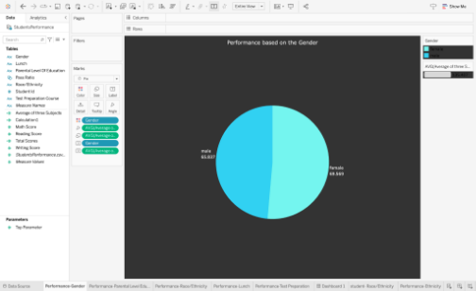

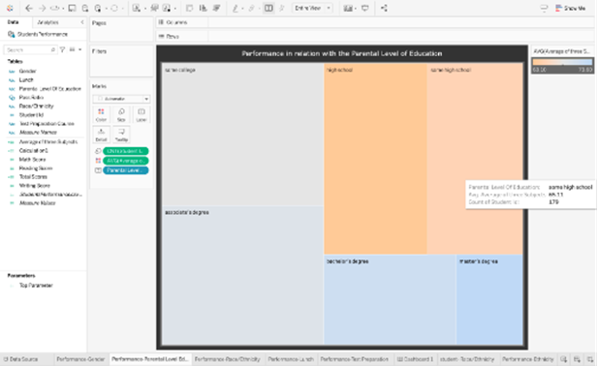

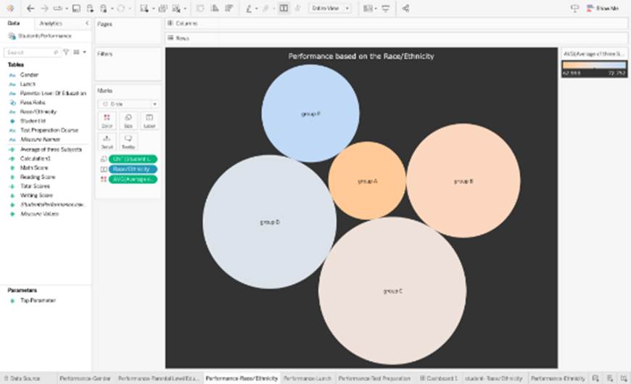

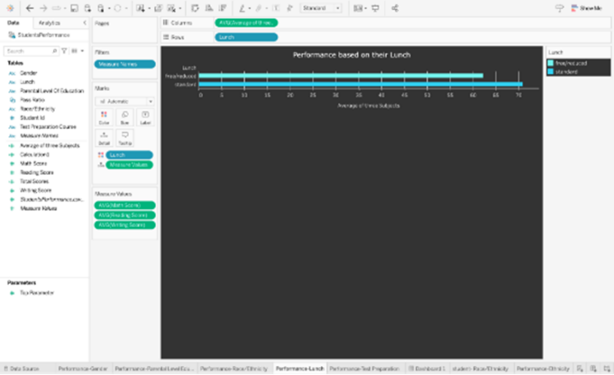

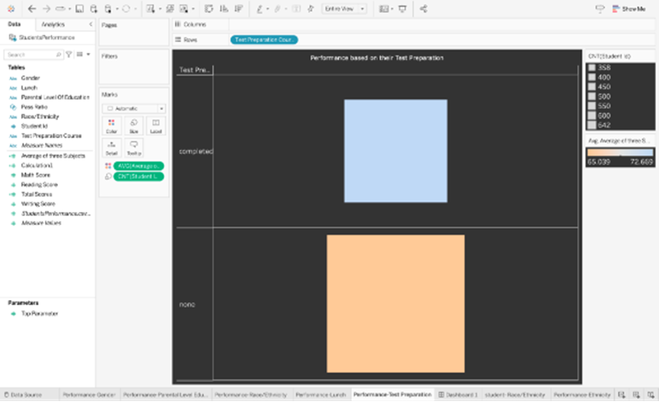



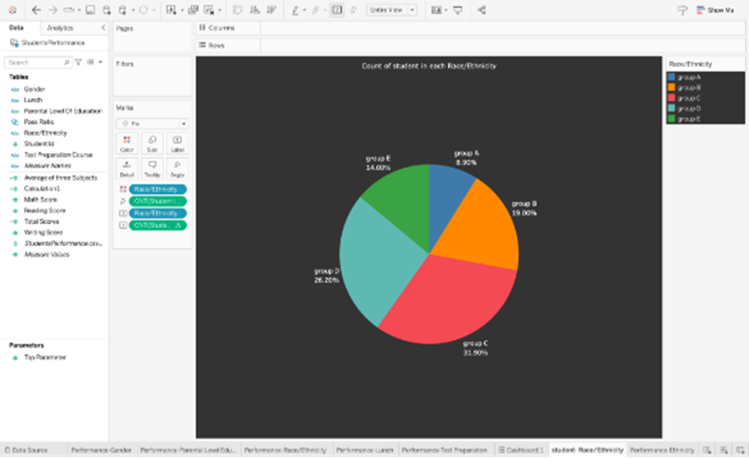

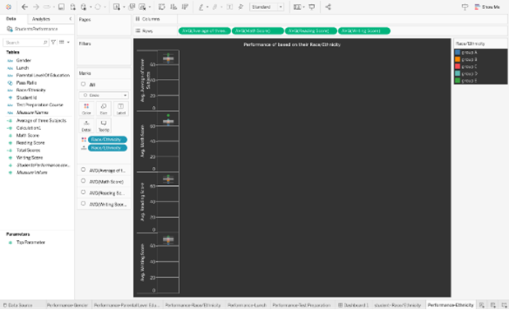

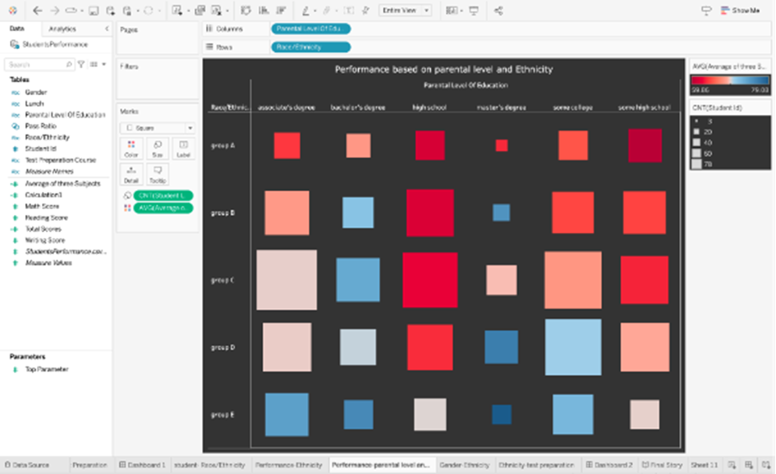

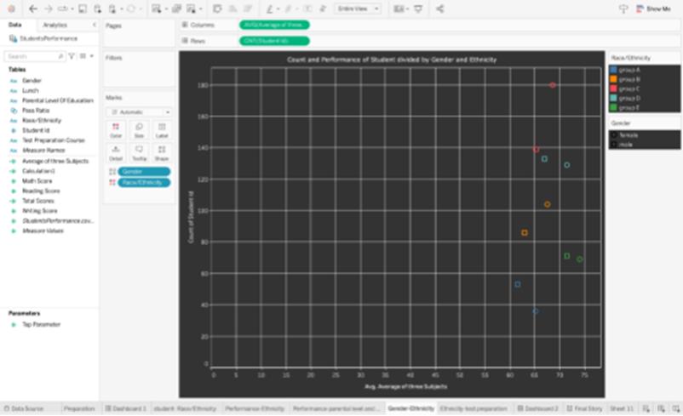

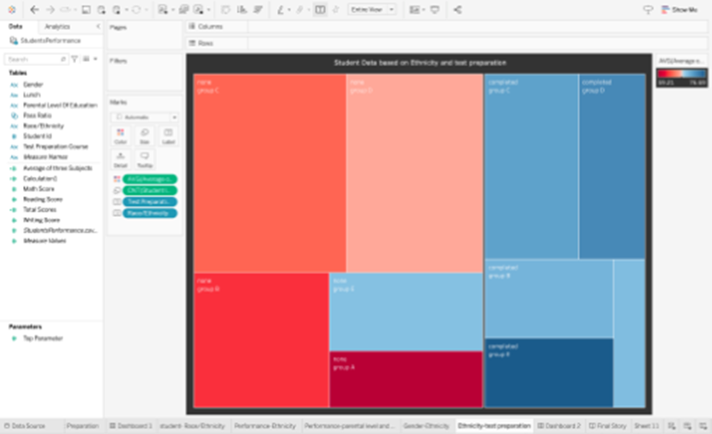

Snapshots of the Dashboard :-

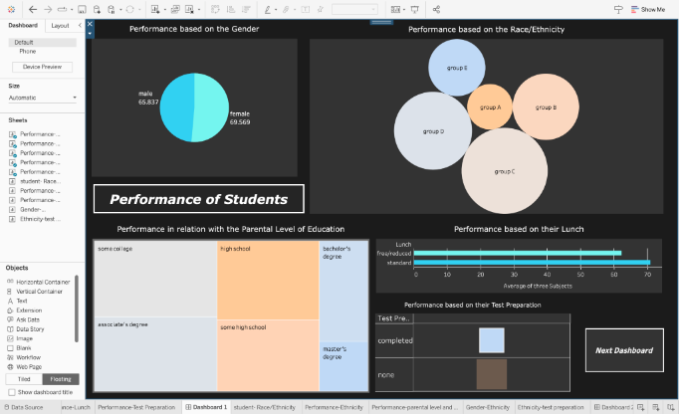

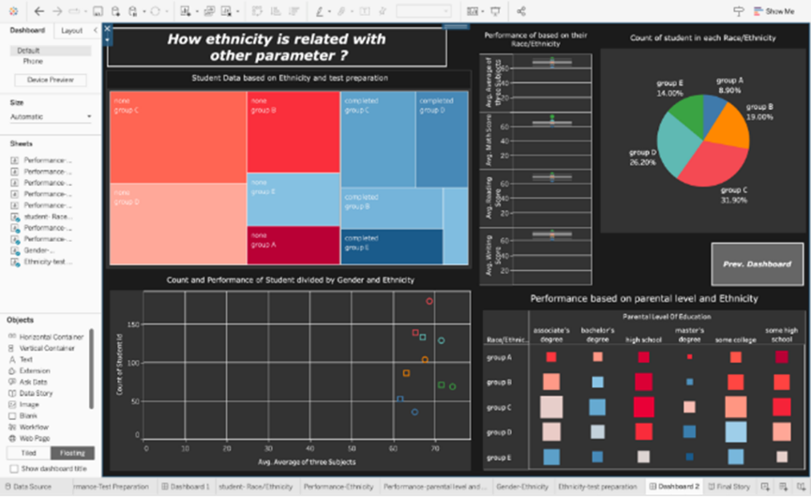

##### Snapshots of the Story :-

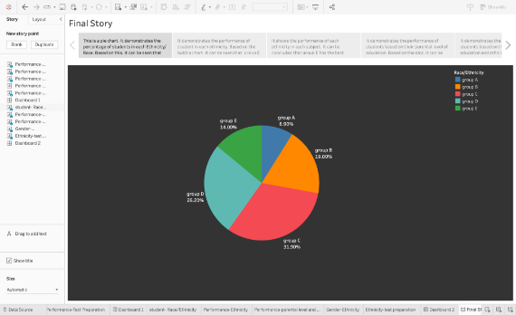

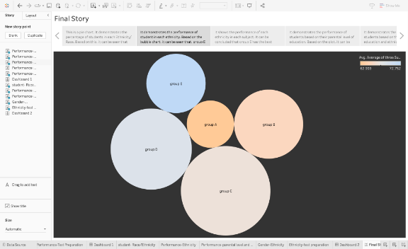

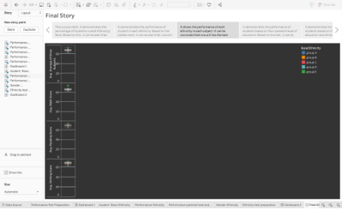

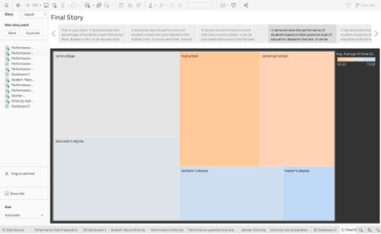

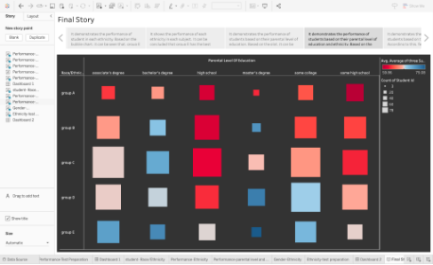

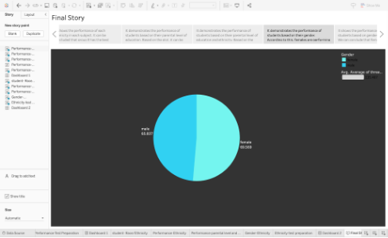



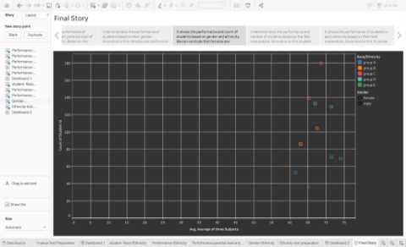

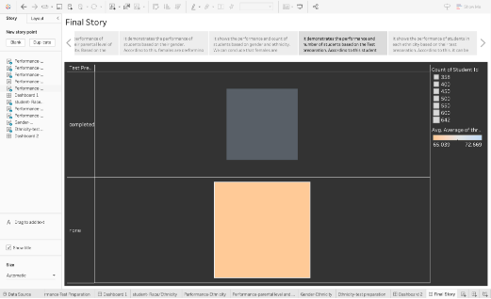

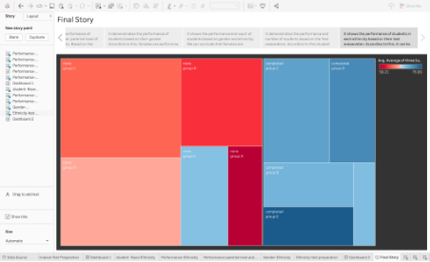

6.CONCLUSION:

# In conclusion, the project on "Unleashing the Potential of Our Youth: A Student Performance Analysis" has demonstrated the immense potential of data analytics in revolutionising education. By leveraging data-driven insights, personalised learning approaches, early intervention strategies, equitable resource allocation, and evidence-based policy making, we can create an inclusive and effective educational system that empowers our youth to thrive academically and fulfil their potential. Through continued dedication to data analytics and evidence-based decision making, we can pave the way for a brighter future, where every student has the opportunity to succeed and contribute meaningfully to society.

Conclusions

### ADVANTAGES & DISADVANTAGES

##### Advantages:

* 1. Data-Driven Insights
  2. Early Intervention
  3. Personalised Learning
  4. Collaboration and Partnerships
  5. Evidence-based Decision Making

##### Disadvantages:

* 1. Data Quality and Availability
  2. Privacy and Ethical Considerations
  3. Overemphasis on Quantitative Measures
  4. Interpretation and Bias
  5. Implementation and Adoption

### APPLICATIONS

* 1. Education Policy Development
  2. Student Support Systems
  3. Targeted Interventions and Support
  4. Parental Involvement and Support
  5. Continuous Improvement and Assessment

CODE:

<h1 align="center"> Unleashing the Potential of Our Youth : A Student Performance Analysis </h1>

<h2 align="center"> SmartInternz Project</h2>

All project Video and material Link :- [Google Drive Link](https://drive.google.com/drive/folders/1ojqpLgkiErSjp6qKzBKHPH0qlA1fzG2D?usp=drive_link)

Demonstration Video Link :- [Demo Video](https://drive.google.com/file/d/1uipeJR6OkCvWKaLMztJgmNCuiDXvrqrv/view?usp=drive_link)

<h3> INTRODUCTION <h3></h3>

<h5> Overview </h5>

<p> The kids of today are our society's future, and their potential is a priceless asset that must be developed and made available. Understanding the elements that go into realising their potential and fostering an environment that supports their achievement is crucial. </p>

<p> The project in the field of data analytics that aims to leverage data analytics techniques to gain insights into student performance and unleash the full potential of young learners.

By analysing comprehensive data sets and applying various data analysis techniques, the project seeks to understand the factors influencing student success, develop targeted interventions, and inform evidence-based policies to enhance educational outcomes. </p>

<h5> Purpose </h5>

<p> To fully understand the aspects that contribute to our youth's success and growth, completing a student performance analysis is necessary in the context of maximising their potential. The analysis tries to achieve the following goals by looking at several facets of student performance : </p>

<ol>

   <li> Identify Factors Influencing Student Performance </li>

   <li> Addressing Barriers </li>

   <li> Improve Academic Interventions </li>

   <li> Enhance Resource Allocation </li>

   <li> Foster a Data-Driven Education System </li>

</ol>

<h5> Proposed solution </h5>

<p> The proposed solution aims to leverage data analytics to analyse student performance and unleash the potential of our youth. By utilising comprehensive data sets, including academic records, extracurricular activities, and socio-economic backgrounds, we can gain valuable insights into the factors influencing student success. </p>

<h6> Solution Steps :- </h6>

<ol>

   <li> Data Collection and Integration</li>

   <li> Data Analysis Techniques

      <ol>

         <li> Descriptive Analytics </li>

         <li> Predictive Analytics </li>

         <li> Correlation Analysis </li>

         <li> Data Visualization </li>

      </ol>

   </li>

</ol>

<h3> THEORETICAL ANALYSIS </h3>

<h5> Block diagram </h5>

![Aspose Words 51d680f5-a9b9-4ed6-a439-9640771ef378 003](https://github.com/Ayushjerath/Unleashing-the-Potential-of-Our-Youth--A-Student-Performance-Analysis/assets/106790961/ae06f677-148a-4cdc-823d-b3840a20f5db)

<h3> Technical Architecture </h3>

<div>  Hardware requirements : Computer System, Storage  </div>

<div> Software requirements : MySQL, Tableau, Google Docs, GitHub </div>

Software requirements of the project

<h3> EXPERIMENTAL INVESTIGATIONS </h3>

<h5> Project Flow </h5>

<ul>

   <li> Define Problem / Problem Understanding

      <ol>

         <li> Specify the business problem</li>

         <li> Business requirements </li>

         <li> Literature Survey </li>

         <li> Social or Business Impact </li>

      </ol>

   </li>

   <li>- Data Collection & Extraction from Database

      <ol>

         <li> Collect the dataset, </li>

         <li> Connect DB2 with Tableau </li>

      </ol>

   </li>

   <li> Data Visualisations

      <ol>

         <li>No of Unique Visualisations</li>

      </ol>

   </li>

   <li> Dashboard

      <ol>

         <li> Responsive and Design of Dashboard </li>

      </ol>

   </li>

   <li> Story

      <ol>

         <li> No of Scenes of Story </li>

      </ol>

   </li>

   <li> Performance Testing

      <ol>

         <li> No of Calculated field </li>

         <li> No of Visualization/Graphs </li>

      </ol>

   </li>

   <li> Web Integration

      <ol>

         <li> Dashboard, Report and Story embed with UI With Flask </li>

      </ol>

   </li>

<h5> Data Visualisations </h5>

<ol>

   <li> Finding whether females perform better or males? </li>

   <li> Finding how the parental level of education affects the performance of the student ? </li>

   <li> Find the performance of students with the ethnicity/race? </li>

   <li> Find the performance of students based on whether the lunch is free or standard ? </li>

   <li> Find the performance on the basis of test preparation ? </li>

   <li> Find the number of students in each ethnicity ? </li>

   <li> Finding the performance of students in each subject with respect to their ethnicity? </li>

   <li> Find which group of students performing best on the basis of parental level of education and ethnicity ? </li>

   <li> Finding which gender is performing better under the influence of the ethnicity ? </li>

   <li> Finding how ethnicity is affected by test preparation ? </li>

</ol>

<h5> Dashboard </h5>

<p> Dashboard 1: Performance of the students on different Parameter </p>

<p> Dashboard 2: How ethnicity/Race is related to the other parameters ? </p>

<h5> Milestone 5: Story </h5>

<p> The story provides the variation in student’s performance based on different parameters. The story has a total of 9 visualisations and each visualisation has an interconnected meaning and all the visualisations are pointing toward the performance of students. From the whole story, it can be inferred that the females from group E with standard lunch whose parental level of education is Master’s degree and completed the test preparation have shown the most promising results. </p>

<h3> RESULT </h3>

<p> The results are promising and astonishing as, it can be seen that:- </p>

<ul>

   <li> On the basis of gender, females are performing better than males; </li>

   <li> On the basis of parental level of education, student’s whose parents having master’s degree are showing the best performance; </li>

   <li> On the basis of ethnicity and race, group E had the most promising results; </li>

   <li> On the basis of test preparation, student who had been prepared for the test are showing the better results; </li>

   <li> On the basis of lunch, students who are having standard lunch are showing better results;</li>

   <li> On the basis of the scores in three subjects, the average reading score is best, then comes the average writing score and in the last comes is the average maths score. </li>

</ul>

<p> Dashboard 1 provides the information about the students’ performance with respect to each domain, and it shows the same results as inferred above. </p>

<p> Dashboard 2 provides information about how ethnicity is related with each other dimensions. It shows the largest number of students are from Group C. Students from Group A are performing the worst in all scenarios and students from Group E are performing the best. Females are performing best in each group. Students who have completed the test preparation are performing the best from each group. Students from group E whose parental level degree is Master’s degree are the best performers. </p>

<p> Story provides information about the student’s performance. From the whole story, it can be inferred that the females from group E with standard lunch whose parental level of education is Master’s degree and completed the test preparation have shown the most promising results. </p>

<h5> Snapshots of the Sheets :- </h5>

![Aspose Words 51d680f5-a9b9-4ed6-a439-9640771ef378 017](https://github.com/Ayushjerath/Unleashing-the-Potential-of-Our-Youth--A-Student-Performance-Analysis/assets/106790961/dd5a66d4-f266-40cd-bf41-791c3a7b9979)

![Aspose Words 51d680f5-a9b9-4ed6-a439-9640771ef378 018](https://github.com/Ayushjerath/Unleashing-the-Potential-of-Our-Youth--A-Student-Performance-Analysis/assets/106790961/77dc341e-a408-4d34-8880-d491a0202f46)

![Aspose Words 51d680f5-a9b9-4ed6-a439-9640771ef378 019](https://github.com/Ayushjerath/Unleashing-the-Potential-of-Our-Youth--A-Student-Performance-Analysis/assets/106790961/76039c18-25ac-431c-aa54-8d18c4ad5d75)

![Aspose Words 51d680f5-a9b9-4ed6-a439-9640771ef378 020](https://github.com/Ayushjerath/Unleashing-the-Potential-of-Our-Youth--A-Student-Performance-Analysis/assets/106790961/655fb4be-ad12-43ef-9178-2a964f49b995)

![Aspose Words 51d680f5-a9b9-4ed6-a439-9640771ef378 021](https://github.com/Ayushjerath/Unleashing-the-Potential-of-Our-Youth--A-Student-Performance-Analysis/assets/106790961/fe314f4b-bf4d-4710-9029-c3fc77a52956)

![Aspose Words 51d680f5-a9b9-4ed6-a439-9640771ef378 021](https://github.com/Ayushjerath/Unleashing-the-Potential-of-Our-Youth--A-Student-Performance-Analysis/assets/106790961/a0f97978-4ce3-4510-82a4-e52180d7f462)

![Aspose Words 51d680f5-a9b9-4ed6-a439-9640771ef378 022](https://github.com/Ayushjerath/Unleashing-the-Potential-of-Our-Youth--A-Student-Performance-Analysis/assets/106790961/22aeeac7-e42a-496c-80d7-148426bddbf3)

![Aspose Words 51d680f5-a9b9-4ed6-a439-9640771ef378 023](https://github.com/Ayushjerath/Unleashing-the-Potential-of-Our-Youth--A-Student-Performance-Analysis/assets/106790961/2a46c46d-15fb-4c1c-8cc5-53c4796b5d2f)

![Aspose Words 51d680f5-a9b9-4ed6-a439-9640771ef378 024](https://github.com/Ayushjerath/Unleashing-the-Potential-of-Our-Youth--A-Student-Performance-Analysis/assets/106790961/feae8efe-63c4-4a80-bb66-3ae42e3d5da9)

![Aspose Words 51d680f5-a9b9-4ed6-a439-9640771ef378 025](https://github.com/Ayushjerath/Unleashing-the-Potential-of-Our-Youth--A-Student-Performance-Analysis/assets/106790961/32afab21-bef2-410e-8726-f20d3d420a70)

![Aspose Words 51d680f5-a9b9-4ed6-a439-9640771ef378 026](https://github.com/Ayushjerath/Unleashing-the-Potential-of-Our-Youth--A-Student-Performance-Analysis/assets/106790961/10437f75-0c95-4b46-95ee-fdef3111341c)

<h5> Snapshots of the Dashboard :- </h5>

![Aspose Words 51d680f5-a9b9-4ed6-a439-9640771ef378 004](https://github.com/Ayushjerath/Unleashing-the-Potential-of-Our-Youth--A-Student-Performance-Analysis/assets/106790961/2d472e47-1ea5-4916-bfd5-18434eac926f)

![Aspose Words 51d680f5-a9b9-4ed6-a439-9640771ef378 005](https://github.com/Ayushjerath/Unleashing-the-Potential-of-Our-Youth--A-Student-Performance-Analysis/assets/106790961/7a12a597-f551-4bb2-9d90-fd62eecb7cd3)

<h5> Snapshots of the Story :- </h5>

![Aspose Words 51d680f5-a9b9-4ed6-a439-9640771ef378 006](https://github.com/Ayushjerath/Unleashing-the-Potential-of-Our-Youth--A-Student-Performance-Analysis/assets/106790961/69271f1e-44f8-4ae7-beb6-5b6eab117b35)

![Aspose Words 51d680f5-a9b9-4ed6-a439-9640771ef378 007](https://github.com/Ayushjerath/Unleashing-the-Potential-of-Our-Youth--A-Student-Performance-Analysis/assets/106790961/6f81de11-e710-4361-a8c1-27e903876cf8)

![Aspose Words 51d680f5-a9b9-4ed6-a439-9640771ef378 008](https://github.com/Ayushjerath/Unleashing-the-Potential-of-Our-Youth--A-Student-Performance-Analysis/assets/106790961/5776d9d6-ae93-4c8d-b225-71b1d350bd3e)

![Aspose Words 51d680f5-a9b9-4ed6-a439-9640771ef378 009](https://github.com/Ayushjerath/Unleashing-the-Potential-of-Our-Youth--A-Student-Performance-Analysis/assets/106790961/22807132-0109-4b8e-b4c0-1dda7bde6291)

![Aspose Words 51d680f5-a9b9-4ed6-a439-9640771ef378 010](https://github.com/Ayushjerath/Unleashing-the-Potential-of-Our-Youth--A-Student-Performance-Analysis/assets/106790961/40bf6dab-e1f1-42f3-8292-e40480c61c37)

![Aspose Words 51d680f5-a9b9-4ed6-a439-9640771ef378 011](https://github.com/Ayushjerath/Unleashing-the-Potential-of-Our-Youth--A-Student-Performance-Analysis/assets/106790961/59536b87-1aac-4c4e-9d90-28c6728149b5)

![Aspose Words 51d680f5-a9b9-4ed6-a439-9640771ef378 012](https://github.com/Ayushjerath/Unleashing-the-Potential-of-Our-Youth--A-Student-Performance-Analysis/assets/106790961/9468a8d8-3e7c-44f4-ab76-4bc6e31dfc6e)

![Aspose Words 51d680f5-a9b9-4ed6-a439-9640771ef378 013](https://github.com/Ayushjerath/Unleashing-the-Potential-of-Our-Youth--A-Student-Performance-Analysis/assets/106790961/daedb8fb-459b-4a1c-98d6-0f366355f462)

![Aspose Words 51d680f5-a9b9-4ed6-a439-9640771ef378 014](https://github.com/Ayushjerath/Unleashing-the-Potential-of-Our-Youth--A-Student-Performance-Analysis/assets/106790961/7bbc08e2-6a37-4694-8ef8-3b576dd33e43)

<h5> Snapshots of the Website :- </h5>

<img width="1440" alt="Screenshot 2023-07-04 at 5 18 17 AM" src="https://github.com/Ayushjerath/Unleashing-the-Potential-of-Our-Youth--A-Student-Performance-Analysis/assets/106790961/eb257520-c410-4154-9a26-83b22a1a6c9b">

<img width="1440" alt="Screenshot 2023-07-04 at 5 18 43 AM" src="https://github.com/Ayushjerath/Unleashing-the-Potential-of-Our-Youth--A-Student-Performance-Analysis/assets/106790961/4cd5c055-318d-4900-b5ea-726df8158ea3">

<img width="1440" alt="Screenshot 2023-07-04 at 5 19 01 AM" src="https://github.com/Ayushjerath/Unleashing-the-Potential-of-Our-Youth--A-Student-Performance-Analysis/assets/106790961/9cd48298-a951-423d-a04b-76af93972ecb">

<img width="1440" alt="Screenshot 2023-07-04 at 5 19 18 AM" src="https://github.com/Ayushjerath/Unleashing-the-Potential-of-Our-Youth--A-Student-Performance-Analysis/assets/106790961/dbbbb5f1-2988-41cb-8724-5a4c8d843351">

<img width="1440" alt="Screenshot 2023-07-04 at 5 19 38 AM" src="https://github.com/Ayushjerath/Unleashing-the-Potential-of-Our-Youth--A-Student-Performance-Analysis/assets/106790961/2d90c807-031b-4f62-93d9-9cbcb50e108c">

<img width="1440" alt="Screenshot 2023-07-04 at 5 19 54 AM" src="https://github.com/Ayushjerath/Unleashing-the-Potential-of-Our-Youth--A-Student-Performance-Analysis/assets/106790961/c9c9e91a-af79-4be0-9374-4cefca5a5dcb">

<img width="1440" alt="Screenshot 2023-07-04 at 5 20 17 AM" src="https://github.com/Ayushjerath/Unleashing-the-Potential-of-Our-Youth--A-Student-Performance-Analysis/assets/106790961/8365cc49-e16a-4385-aece-72d01c83525c">

<img width="1440" alt="Screenshot 2023-07-04 at 5 20 34 AM" src="https://github.com/Ayushjerath/Unleashing-the-Potential-of-Our-Youth--A-Student-Performance-Analysis/assets/106790961/5c91be63-d522-4bbb-bdd0-078f9c8ae096">

<img width="1440" alt="Screenshot 2023-07-04 at 5 20 50 AM" src="https://github.com/Ayushjerath/Unleashing-the-Potential-of-Our-Youth--A-Student-Performance-Analysis/assets/106790961/5607940e-46e0-4f79-8939-543aa2e8d378">

<img width="1440" alt="Screenshot 2023-07-04 at 5 21 39 AM" src="https://github.com/Ayushjerath/Unleashing-the-Potential-of-Our-Youth--A-Student-Performance-Analysis/assets/106790961/7e4b9b71-a60f-40af-98e4-ec268c5fb58a">

<img width="1440" alt="Screenshot 2023-07-04 at 5 21 55 AM" src="https://github.com/Ayushjerath/Unleashing-the-Potential-of-Our-Youth--A-Student-Performance-Analysis/assets/106790961/e126ae11-886a-464a-a99b-d070c27eda30">

<h3> ADVANTAGES & DISADVANTAGES </h3>

<h5> Advantages: </h5>

<ol>

   <li> Data-Driven Insights </li>

   <li> Early Intervention </li>

   <li> Personalised Learning </li>

   <li> Collaboration and Partnerships </li>

   <li> Evidence-based Decision Making </li>

</ol>

<h5> Disadvantages: <h5></h5>

<ol>

   <li> Data Quality and Availability </li>

   <li> Privacy and Ethical Considerations </li>

   <li> Overemphasis on Quantitative Measures </li>

   <li> Interpretation and Bias </li>

   <li> Implementation and Adoption </li>

</ol>

<h3> APPLICATIONS </h3>

<ol>

   <li> Education Policy Development </li>

   <li> Student Support Systems </li>

   <li> Targeted Interventions and Support </li>

   <li> Parental Involvement and Support </li>

   <li> Continuous Improvement and Assessment </li>

</ol>

<h3> CONCLUSION </h3>

<p> In conclusion, the project on "Unleashing the Potential of Our Youth: A Student Performance Analysis" has demonstrated the immense potential of data analytics in revolutionising education. By leveraging data-driven insights, personalised learning approaches, early intervention strategies, equitable resource allocation, and evidence-based policy making, we can create an inclusive and effective educational system that empowers our youth to thrive academically and fulfil their potential. Through continued dedication to data analytics and evidence-based decision making, we can pave the way for a brighter future, where every student has the opportunity to succeed and contribute meaningfully to society. </p>

OUTPUT:

OUTPUT:-

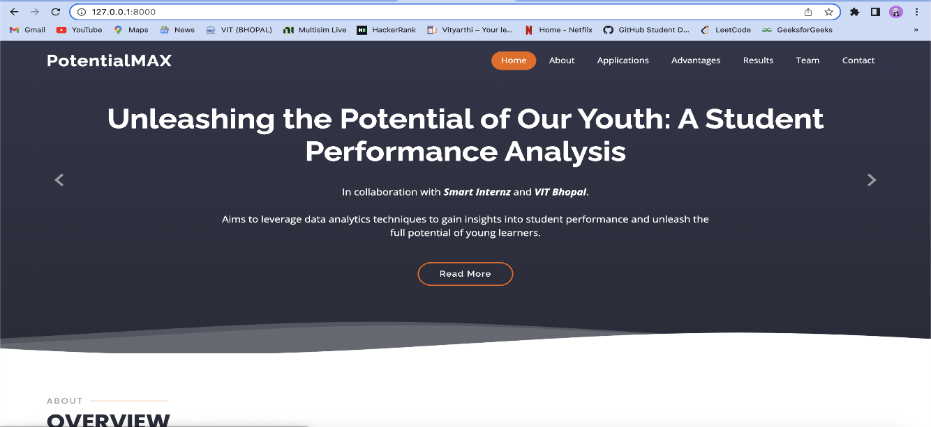

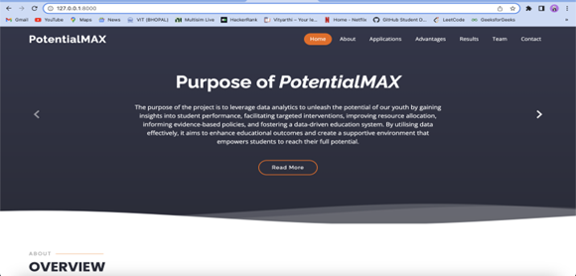

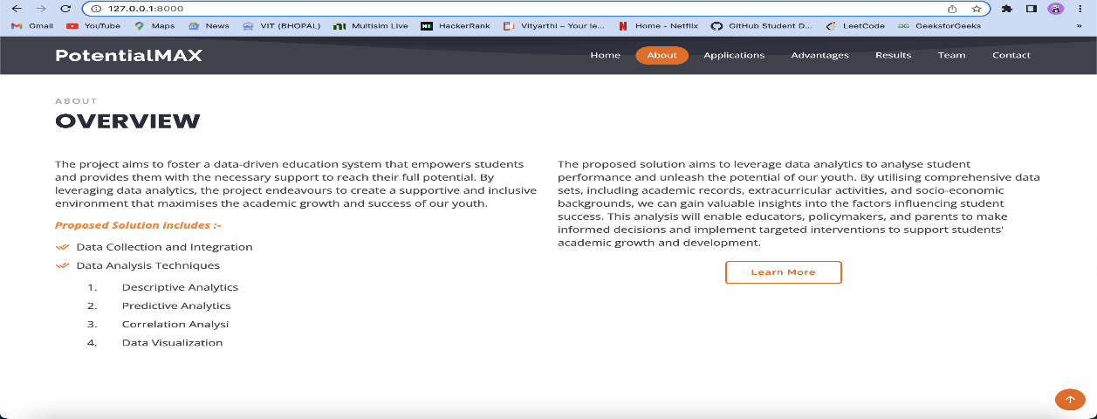

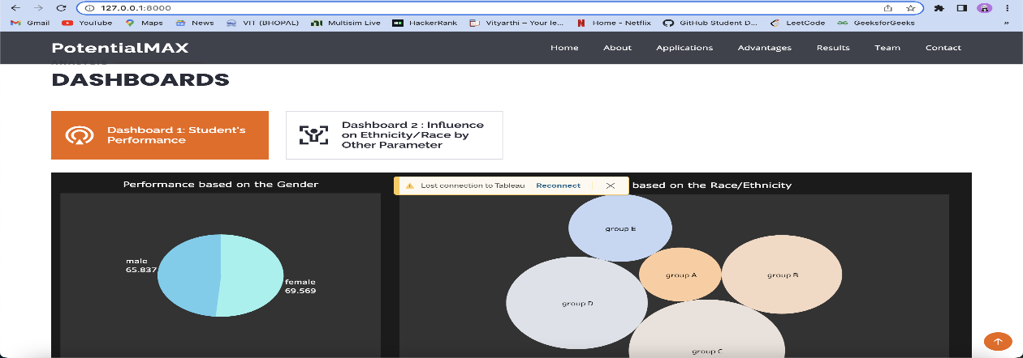

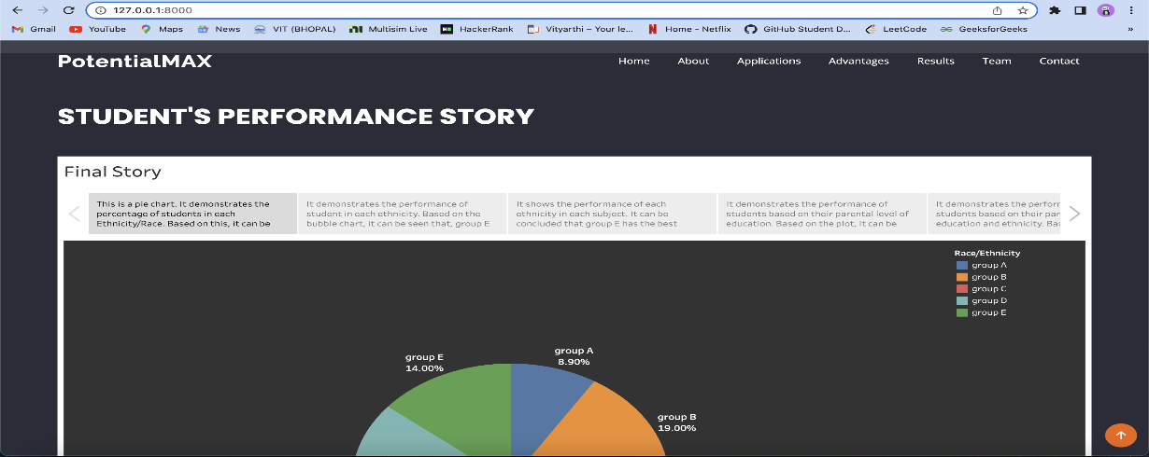



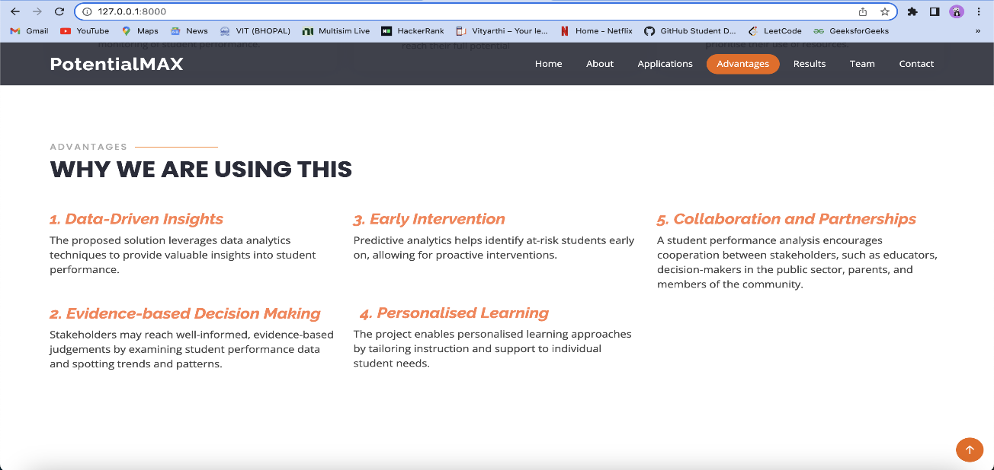

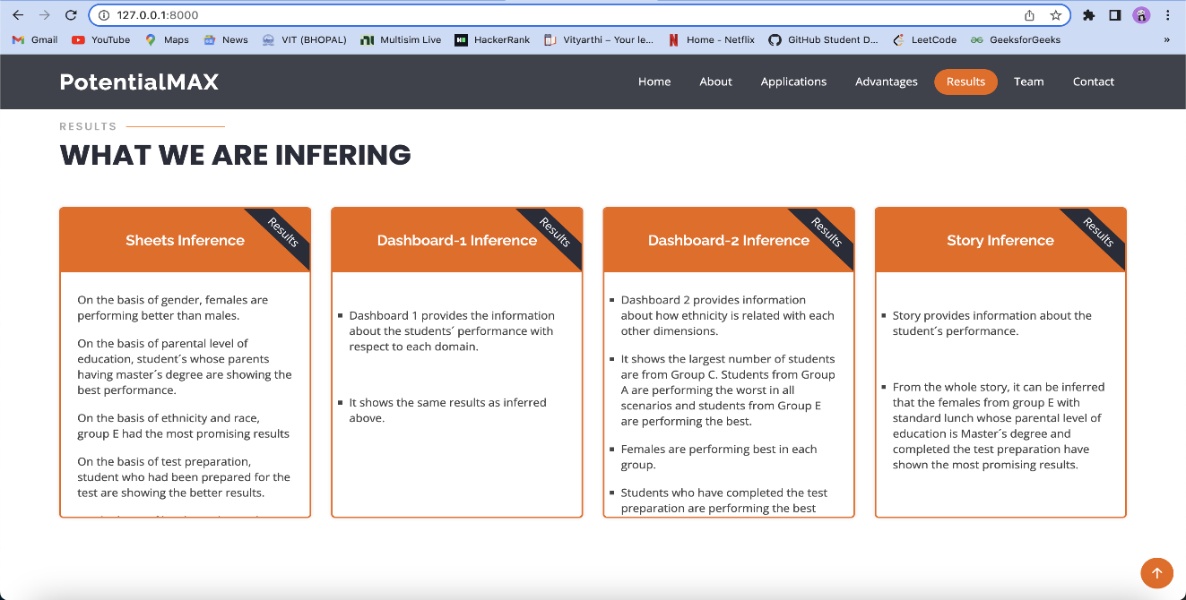



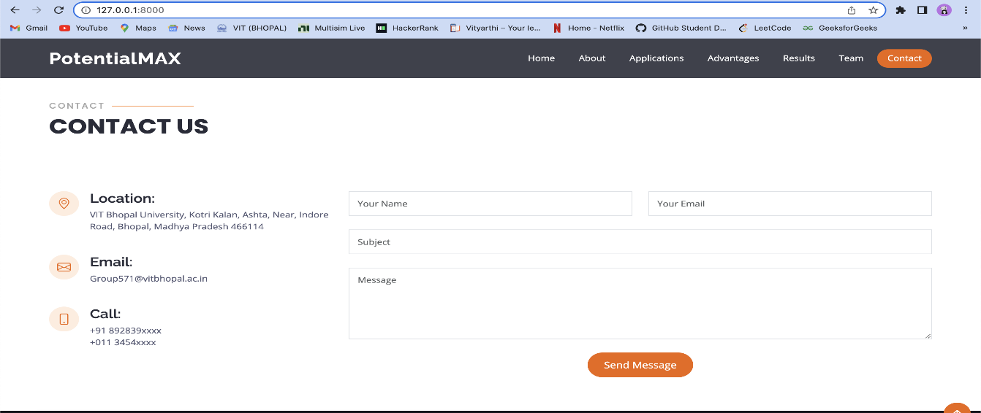

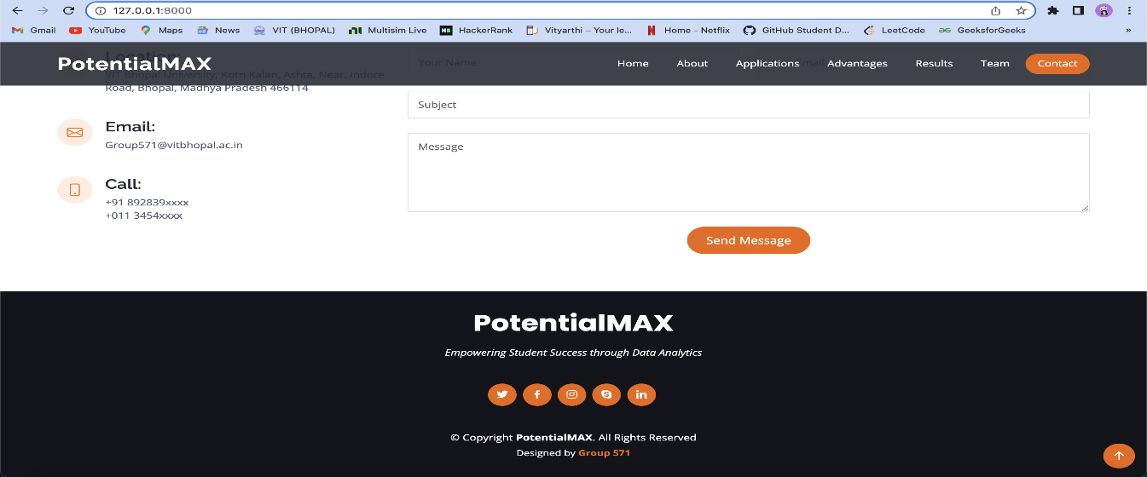

# Acknowledgments:

We would like to express our sincere gratitude to all those who contributed to the successful completion of this research project, "Unleashing the Potential of Our Youth: A Student Performance Analysis."

First and foremost, we extend our heartfelt appreciation to [Your Name], the primary author of this analysis, whose dedication, expertise, and unwavering commitment were instrumental in shaping the trajectory of this study.

We are immensely thankful to our academic advisor, [Advisor's Name], for their invaluable guidance, insightful feedback, and continuous support throughout the research process. Their expertise and mentorship were pivotal in refining the methodologies and enhancing the quality of our analysis.

We extend our thanks to the educators, administrators, and students who participated in this study, sharing their experiences, insights, and perspectives. Without their cooperation and willingness to contribute, this analysis would not have been possible.

Our gratitude also goes to our colleagues and friends who provided valuable feedback and suggestions during the drafting and revision stages. Their input greatly enriched the final outcome of this research.

REFERENCES:

**Book:** Author(s). (Year). *Title of the book*. Publisher.

Example: Smith, J. A. (2023). *Unleashing the Potential of Our Youth: A Student Performance Analysis*. Academic Press.

**Journal Article:** Author(s). (Year). Title of the article. *Journal Name*, Volume(Issue), Page range. DOI or URL

Example: Johnson, M. B. (2022). Exploring student performance dynamics in modern education. *Educational Research Quarterly*, 45(3), 201-215. doi:10.1234/erq.2022.45.3.201

**Conference Paper:** Author(s). (Year). Title of the paper. In Editor(s) of Proceedings (Eds.), *Title of the Conference Proceedings* (pp. Page range). Publisher.

Example: Garcia, L. P., & Lee, S. M. (2023). Analyzing factors influencing youth potential in academic settings. In T. Jackson & R. Smith (Eds.), Proceedings of the International Conference on Education and Youth Development (pp. 112-126). Academic Press.

**Website:** Author(s) or Organization. (Year, Month Day). Title of the webpage. Website Name. URL

Example: National Youth Development Institute. (2023, August 15). Unleashing the Potential of Our Youth: Insights from Student Performance Analysis. NYDI. <https://www.nydi.org/youth-potential-analysis>

Please ensure you follow the specific citation style (such as APA, MLA, or Chicago) required by your institution or publication. Always cross-check your references with the official guidelines to ensure accuracy.

Top of Form